Dear X / Greeting,
We are writing to you about the impact of the Government’s recent Budget announcement, what it means for early years and childcare providers like us and you as families.
You may have seen coverage in the news about increases in statutory minimum wages and national insurance contributions (NICs). Depending on the age of the employee, National Living Wage and National Minimum Wage rates are increasing by between 6.7% and 18%. At the same time, National Insurance Contributions, which we pay per employee, will increase by 1.2% and start being paid at a lower threshold.
The National Day Nurseries Association (NDNA) estimates that for the average full daycare provider with 9 members of staff, the increase in NICs and statutory minimum wages alone will add on average an additional £2,633 a year per employee and £23,700 in total. Our nursery employs xxx staff members (add impact on your own setting here)
On 11 December the Welsh Government published the new Childcare Offer funding rates which will increase from April by 20% from £5 per hour to £6 https://ndna.org.uk/news/wales-funding-rates-revealed-but-20-increase-will-not-cover-all-costs/ We don’t know if the Welsh Government will reimburse private and voluntary nurseries for NIC payments but we don’t believe this increase has been factored into the funding rate amounts.
At this time we do not know how the Welsh Government will take these increases into account in the rates they pay us to deliver early education or Flying Start places [delete as appropriate] available at our setting.
However, historically rates have not kept pace with rising costs. Our last funding rate increase was three years ago and since then we have seen inflation peak at over 11% and statutory wages increase year-on-year. Research by NDNA this year showed that the average staffing costs increases for nurseries across Wales was 15% and that as a result of the freeze to our funding 97% of nurseries in Wales say rates do not cover our costs.
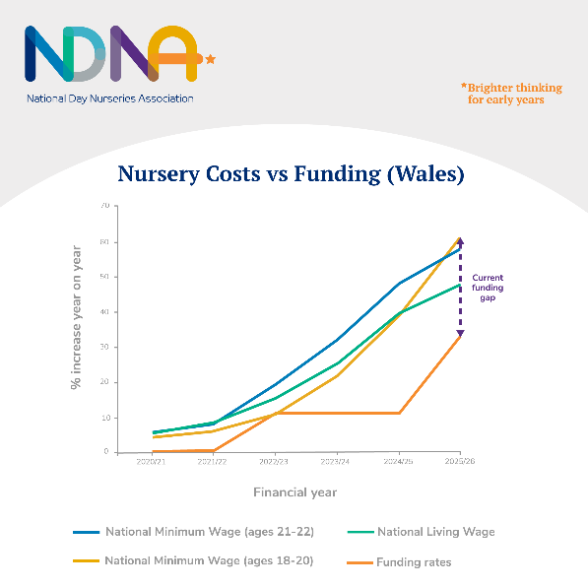
As a result of underfunding and rising costs, NDNA has found that the closures of nurseries have increased nationally. To remain sustainable, nurseries like ours will have to look at our fee structure again.
We know that parents support the view that the government should be reimbursing nurseries to take account of the extra costs they face. While nine in ten parents told Pregnant then Screwed that they felt stressed about the risk of potential childcare cost increases, 92% believe that all childcare providers should be exempt from the NICs increase, as schools are.
We are writing to our local MP/MS XXXXXX to raise this with them. If you are able to contact them with your concerns it could help ensure the Chancellor is aware of the impact of the Budget and the Welsh Government provide better support to early years, minimising the increased costs we have to pass on to parents.
While we appreciate this is difficult for everyone, I hope this information helps you to understand the challenges we face as nursery providers and the difficult choices we are faced with. We also hope you will be able to support us in contacting our local representatives to ask for the support early years and childcare providers need.

Sign off

