Dear X / Greeting,

We are writing to you about the impact of the Government’s recent Budget announcement, what it means for early learning and childcare (ELC) providers like us and you as families.

You may have seen coverage in the news about increases in statutory minimum wages and national insurance contributions (NICs). Depending on the age of the employee, National Living Wage and National Minimum Wage rates are increasing by between 6.7% and 18%. At the same time, national insurance contributions, which we pay per employee, will increase by 1.2% and start being paid at a lower threshold.

The National Day Nurseries Association (NDNA) estimate that for the average nursery with 14 staff, the increase in NICs alone will add on average an additional £2,200 a year per employee and £42,000 in total.

At this time, we do not know how the Scottish Government will take these increases into account in the rates they pay local authorities to fund us to deliver ELC places for your children.

However, historically rates have not kept pace with rising costs. For context, the average funding rate for three and four-year-old places increased by 7.6% this year when we saw the Real Living Wage rise by 10%. Research by NDNA showed that the average staffing costs increases for nurseries across Scotland was 12% and that 70% of Scottish nurseries say that funding hasn’t covered our costs.

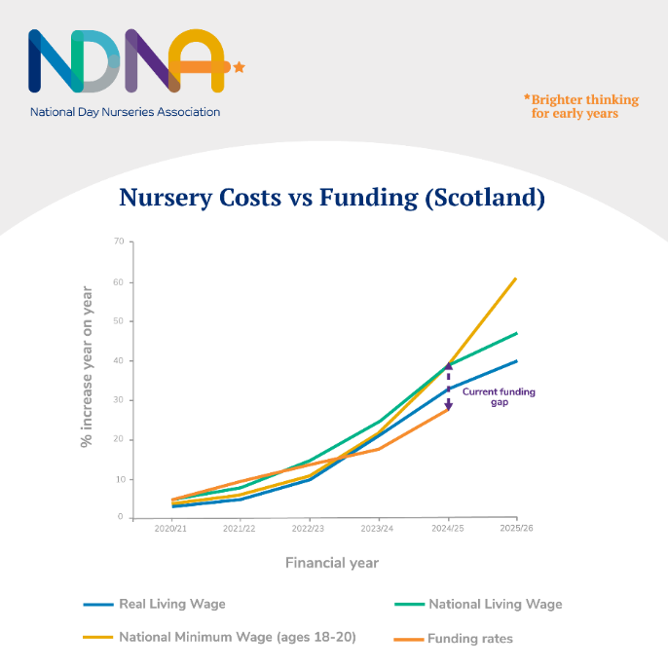As a result of underfunding and rising costs, NDNA has found that the closures of nurseries have increased nationally. To remain sustainable, nurseries like ours will have to look at our fee structure again.

We know that parents support the view that the government should be reimbursing nurseries to take account of the extra costs they face. While nine in ten parents told Pregnant then Screwed that they felt stressed about the risk of potential childcare cost increases, 92% believe that all childcare providers should be exempt from the NICs increase, as schools are.

We are writing to our local MP/MSP XXXXXX to raise this with them and if you are able to contact them with your concerns it could help. The Chancellor needs to be aware of the impact of the Budget and the Scottish Government needs to provide better support to early years, minimising the increased costs we have to pass on to parents.

While we appreciate this is difficult for everyone, I hope this information helps you to understand the challenges we face as nursery providers and the difficult choices we are faced with. We also hope you will be able to support us in contacting our local representatives to ask for the support ELC providers need.

Sign off