Dear X / Greeting,
We are writing to you about the impact of the Government’s recent Budget announcement, what it means for early years providers like us and you as families.
You may have seen coverage in the news about increases in statutory minimum wages and national insurance contributions (NICs). Depending on the age of the employee, National Living Wage and National Minimum Wage rates are increasing by between 6.7% and 18% from April. At the same time, national insurance contributions, which we pay per employee, will increase by 1.2% and start being paid at a lower threshold from April.
The National Day Nurseries Association (NDNA) estimates that for the average nursery with 18 members of staff, the increase in NICs and statutory minimum wages alone will add on average an additional £2,633 a year per employee and £47,000 in total.
On 10 December the Government published the new funding rates which will increase from April on average between 3.3% and 4.1% https://ndna.org.uk/news/england-funding-rates-2025-26-wont-factor-in-national-insurance-contributions/ The Government said that they would not reimburse private and voluntary nurseries for NIC payments and this increase has NOT been factored into the funding rate amounts.
This graph shows the growing gap between staffing costs which make up about 75% of our overall costs and the funding we receive from the Government.
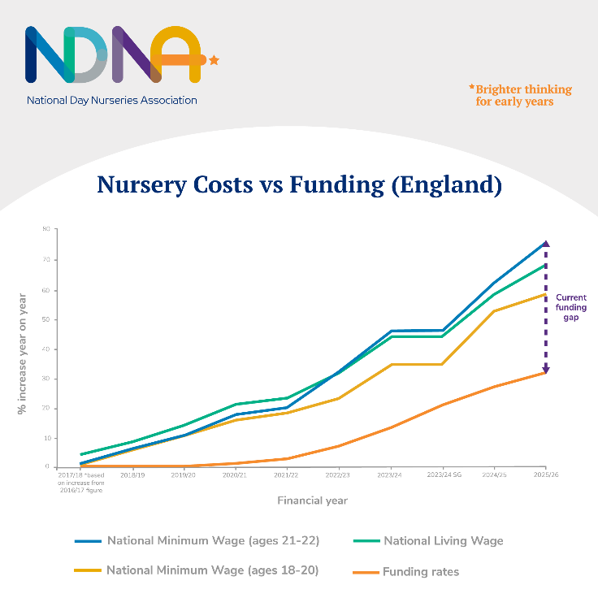
For context, the average funding rate for three and four-year-olds only increased by 4.6% this year when we saw statutory wages rise by around 10%. Research by NDNA showed that the average staffing costs increases for nurseries this year was 14.4% and that the funding for three and four-year-old places is underfunded by around £2.36 per hour per child.
As a result of underfunding and rising costs, NDNA has found that the closures of nurseries have increased nationally. To remain sustainable, nurseries like ours will have to look at our fee structure again.
We know that parents support the view that the government should be reimbursing nurseries to take account of the extra costs they face. While nine in ten parents told Pregnant then Screwed that they felt stressed about the risk of potential childcare cost increases, 92% believe that all childcare providers should be exempt from the NICs increase, as schools are.
We are writing to our local MP XXXXXX to raise this with them and if you are able to contact them with your concerns it could help ensure the Government provide better support to early years, to minimise the increased costs we have to pass on to parents.
While we appreciate this is difficult for everyone, I hope this information helps you to understand the challenges we face as nursery providers and the difficult choices we are faced with. We also hope you will be able to support us in contacting our MP to ask for the support early years providers need.

Sign off

