Dear X / Greeting,
We are writing to you about the impact of the Government’s recent Budget announcement, what it means for early years providers like us and you as families.
You may have seen coverage in the news about increases in statutory minimum wages and national insurance contributions (NICs). Depending on the age of the employee, National Living Wage and National Minimum Wage rates are increasing by between 6.7% and 18%. At the same time, national insurance contributions, which we pay per employee, will increase by 1.2% and start being paid at a lower threshold.
The National Day Nurseries Association (NDNA) estimate that for the average nursery with 14 staff, the increase in NICs alone will add £10,000 - £12,000 a year to operating costs before the impact of statutory wage increase are taken into account.
At this time we do not know how the Government will take these increases into account in the rates they pay us to deliver their funded childcare hours for children from nine-months old.
However, historically rates have not kept pace with rising costs. This graph shows the growing gap between staffing costs alone and the funding we receive.
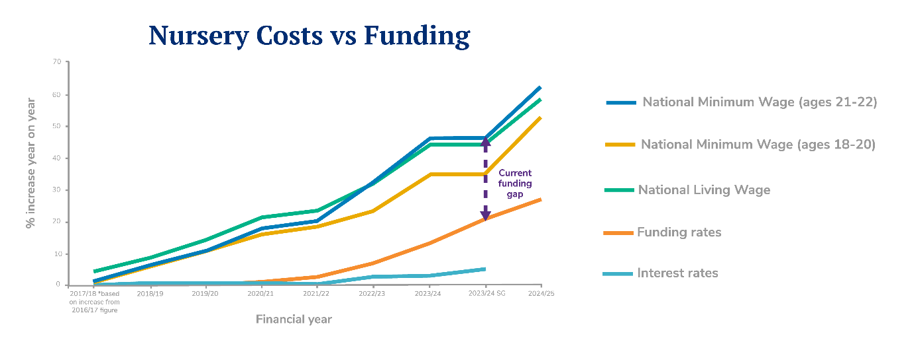
For context, the average funding rate for three and four-year-olds only increased by 4.6% this year when we saw statutory wages rise by around 10%. Research by NDNA showed that the average staffing costs increases for nurseries this year was 14.4% and that the funding for three and four-year-old places is underfunded by around £2.36 per hour per child.
As a result of underfunding and rising costs, NDNA has found that the closures of nurseries have increased nationally. To remain sustainable, nurseries like ours will have to look at our fee structure again.
We know that parents support the view that the government should be reimbursing nurseries to take account of the extra costs they face. While nine in ten parents told Pregnant then Screwed that they felt stressed about the risk of potential childcare cost increases, 92% believe that all childcare providers should be exempt from the NICs increase, as schools are.
We are writing to our local MP XXXXXX to raise this with them and if you are able to contact them with your concerns it could help ensure the Government provide better support to early years, to minimise the increased costs we have to pass on to parents.
While we appreciate this is difficult for everyone, I hope this information helps you to understand the challenges we face as nursery providers and the difficult choices we are faced with. We also hope you will be able to support us in contacting our MP to ask for the support early years providers need.

Sign off

