Dear X / Greeting,
We are writing to you about the changes in Government funded childcare which began in April and what it means for families and providers like us. You may have seen coverage in the news that childcare providers across the country are facing a lot of uncertainty around the expanded offer. We have been working hard to get ready for this roll-out. [use if appropriate - but it has not been easy with delays in information on funding rates from xxxxxxx council].
As you know, we have had to make the difficult decision to amend our fees this year by [add detail of fee changes here].
As providers we have faced a number of challenges ahead of this roll-out including ongoing underfunding of the places for three and four-year-old children. We have also seen inflation which is still running at 3.4%, but peaked at 11%. This has meant that everything from our energy bills, food costs and learning resources are more expensive than last year. From April this year we have also seen statutory minimum wages rise by around 10% and we have to look at pay across our setting on the back of this. For context, the average funding rate for three and four-year-olds has only increased by 4.6%.
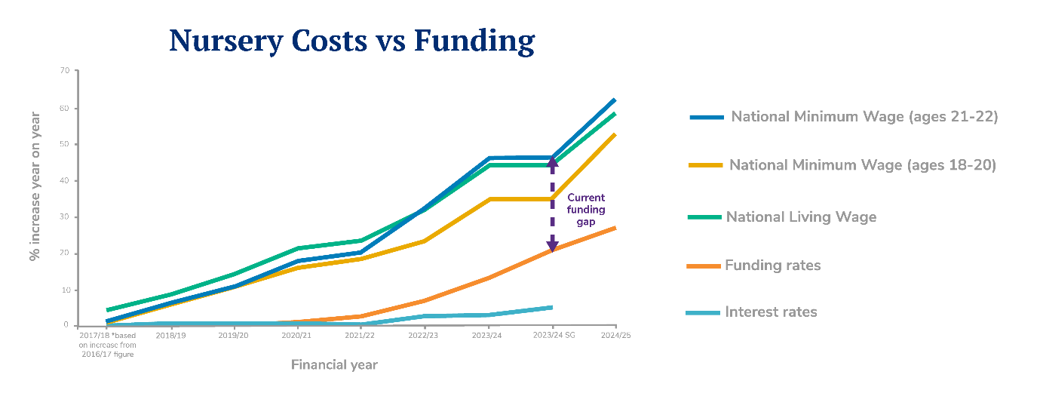
Research by the National Day Nurseries Association (NDNA) shows that the average staffing costs increases for nurseries this year are 14.4% and that the funding for three and four-year-old places is underfunded by around £2.36 per hour per child. As a result of underfunding and rising costs, NDNA has found that the closures of nurseries have increased nationally. To remain sustainable, nurseries like ours have had to look at our fee structure.
In xxxxxxx council area, we receive £X.XX per hour per child for three and four-year-olds and £X.XX for two-year-olds. All early years settings are different and have different costs but for us this means we can only just cover our costs / we lose £X.XX an hour on funded childcare places.
This year, our business rates have also increased to £XXXXX which is a tax we have to pay on the space we provide our children to learn, grow and develop. As more hours in settings are Government paid, we are less able to cover costs like these due to chronic underfunding.
There is a lot of coverage in the media about fee increases and the cost of childcare. We are very aware of the pressures on you as parents and carers and we therefore try to keep our fee increases as low as possible. As you know we have recently implemented a XX% change to our fees even though our costs have increased by XX%.
While we appreciate this is difficult for everyone, I hope this information helps you to understand the challenges we face as nursery providers and the difficult choices we are faced with.
[You may want to provide additional information about the services or sessions you provide as appropriate]
Sign off

