Dear X, [You can find details of your local MP by entering your postcode here - https://www.writetothem.com/]
I am [job title] of [name of setting] in [area/town/village] in your constituency and we currently have [xx] children aged between X to X attend our setting. We provide high quality early education and childcare which gives children an excellent start in life while also supporting working families.
[You may want to add some information here about what you think makes your nursery special]
You may have seen coverage in the news that childcare providers across the country are facing a lot of uncertainty around the Government’s expanded offer of funded childcare to two-year-olds. We have been working hard to get ready for this roll-out. [use if appropriate - but it has not been easy with delays in information on funding rates from xxxxxxx council].
As providers we have faced a number of challenges ahead of this roll-out including ongoing underfunding of the places for three and four-year-old children. We have also seen inflation which still running at 3.4%, but peaked at 11%. This has meant that everything from our energy bills, food costs and learning resources are more expensive than last year. From April this year we have also seen statutory minimum wages rise by around 10% and we have to look at pay across our setting on the back of this. For context, the average funding rates funding rates have increased by 27% since 2017 but wages have risen by 58 – 62% in the same time period.
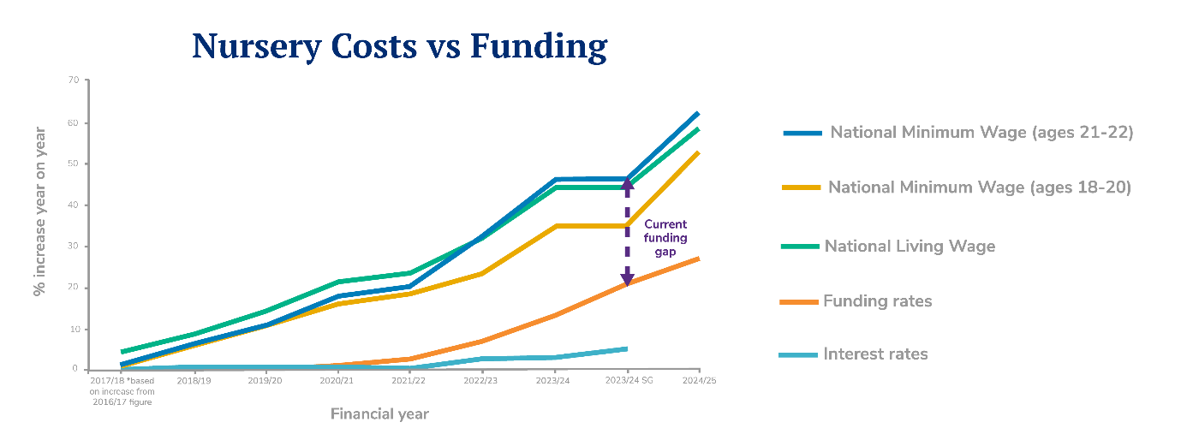
Research by the National Day Nurseries Association (NDNA) shows that the average staffing cost increases for nurseries this year are 14.4% and that the funding for three and four-year-old places is underfunded by around £2.36 per hour per child. As a result of underfunding and rising costs, NDNA has found that the closures of nurseries have increased nationally. To remain sustainable, nurseries like ours have had to look at our fee structure.
In xxxxxxx council area, we receive £X.XX per hour per child for three and four-year-olds and £X.XX for two-year-olds. All early years settings are different and have different costs but for us this means we can only just cover our costs / we lose £X.XX an hour on funded childcare places.
This year, our business rates have also increased to £XXXXX which is a tax we have to pay on the space we provide our children to learn, grow and develop. As more hours in settings are Government paid, we are less able to cover costs like these due to chronic underfunding.
There is a lot of coverage in the media about fee increases and the cost of childcare. We are very aware of the pressures on parents and carers and we therefore try to keep our fee increases as low as possible. We have recently implemented a XX% change to our fees even though our costs have increased by XX%.
While we welcome the efforts to increase investment in children’s crucial early years, if we are to be able to offer the places families need in a sustainable way we need support. I am asking you if you will do any of the following things to help my nursery and others like me: (Delete as appropriate)
- Please write to the Chancellor to ask him to provide Business Rates relief to nurseries. The IFS estimates that the Government will soon be purchasing 80% of childcare hours and research from National Day Nurseries Association suggests that the average business rates bill is more than £21,000. [Please add your own example if it helps] This is an additional financial burden, making it more difficult for my setting to operate and it is a disincentive to taking on more children or expanding my setting.
- Please urge the Secretary of State for Education to make more capital funding available for early years settings. The Government announced £100m last year to support early years and wraparound care expansion. However, this amounts to around £650,000 per local authority while and NDNA found that 54% of nurseries surveyed would need some capital grant support to make the changes necessary to offer increased childcare places.

I really hope you will be able to speak up for nurseries like mine and the children and families across [constituency] who rely on us. If you aren’t able to do any of the actions above but would like to support us in other ways, please let me know what you will be able to do as any support would be greatly appreciated.

Sign off

